EGS Collab Testbed 2 Fractures and Visualizations
Ghanashyam Neupane, N. Uzunlar, W. Roggenthen, Craig Ulrich, and EGS Collab Team
A document prepared as an appendix to EGS Collab Final Project Report (Tim Kneafsey et al., 2023)

1. Introduction
The EGS Collab Project performed a series of tests to increase the understanding the response of crystalline rock mass to stimulations and fluid circulation to efficiently implement enhanced geothermal systems (EGS) technologies. The EGS Collab team created two underground testbeds (Figure 1) at the Sanford Underground Research Facility (SURF) in Lead SD at a depth of approximately 1.5 km (4850 level) and 1.25 km (4100 level) to examine hydraulic fracturing and hydraulic shearing, respectively. Experiment 2 was designed to examine hydraulic shearing and fluid flow in testbed 2 in amphibolite under a controlled set of stress and fracture conditions. This document summarizes the general geology, natural fractures, and conceptual model(s) of stimulated fracture networks in the testbed 2.

2. Geology
EGS Collab testbed 2 was constructed entirely within the Yates Unit of the Poorman Formation. Yates unit consists of amphibolite that shows strong textural (grain-size) as well as compositional layering (hornblende and plagioclase). Amphibolite is cross-cut by calcite veins (Caddey et al. 1991). Along with these calcite veins, local oxidized sulfide layers define the zones of weakness in the rock. At the testbed site, the host rock consists of amphibole, plagioclase, and chlorite with minor amounts of sulfides.
Structurally, the testbed is located on the eastern limb of a southerly plunging Lead Anticline (Figure 1). Over the geologic history, the host rock was subject to multi-deformation phases and igneous intrusions. Some of the noted deformation occurred during the Precambrian (Paleoproterozoic) time that created fractures which were subsequently healed with vein minerals consisting primarily of calcite and quartz. During the Tertiary (Paleogene) time, rhyolitic intrusions occurred that resulted a series of fractures and shear zones. Tertiary rhyolite dikes, mostly striking along NW-SE direction, intersect several geologic units in the area including Yates. Most of the rhyolite dikes in the vicinity of testbed are located to the western side; however, one of the exploratory holes (e.g., Borehole TV4100) encountered a thick rhyolite dike, and it is expected that this rhyolite body is extended to the area underneath the stimulated volume of rock in the testbed 2 (Figure 1).
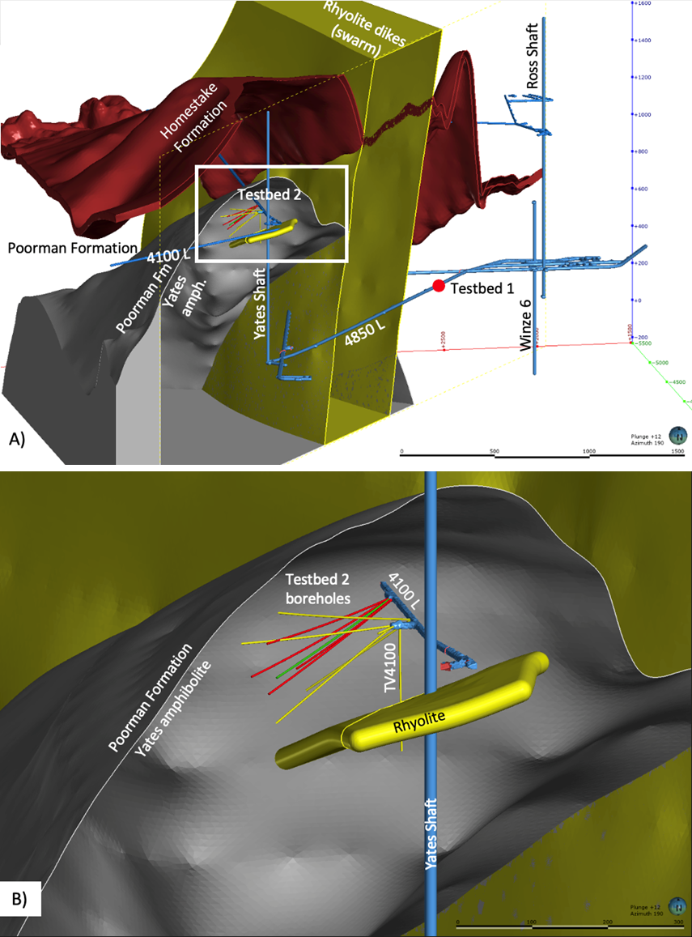
Figure 1. Location of EGS Collab testbeds. (A) Testbed 1 is located entirely within metasediments of the Poorman Formation on the western limb of Lead Anticline, and Testbed 2 is located in the metabasalt (amphibolite) of Yates unit of the Poorman Formation on the eastern limb of the anticline. (B) Enlarged region showing Testbed 2, the host rock, and location of the rhyolite encountered in an exploratory hole (TV4100). The grouted-monitoring wells are yellow and open test wells are red and green.

3. Fractures along the Drift (N. Uzulnar and W. Roggenthen, SDSMT)
Prior to the construction of testbed 2, a detailed fracture mapping (Figure 2) was conducted along the 4100-level drift south from the Yates Shaft and Battery Alcove. The exposure of fractures varied from excellent within the battery alcove to adequate in the drift. The fresh face at the end of the battery alcove allowed the full extent of fracturing to be seen and showed many healed and, sometimes, unhealed fractures. The fine-scale fracturing identified in the alcove was not as evident in the drifts due to lack of fresh surfaces, although the larger features were still evident in the drifts.
Mapping in the drifts extended from about 100 ft in the direction of the Yates Shaft from the battery alcove and then southward to the contact between the Yates and Ross Members of the Poorman Fm. Locations of fractures, identification of type of fractures, and orientations were recorded as part of this exercise. The results of the mapping are included Figure 2.

3.1 Types of Fractures
Three main types of fractures near the battery alcove were identified. They include: 1) large fractures that may have experienced shearing, 2) foliation-parallel features and 3) small width, healed fractures that may be conjugate shear sets. Although many small joints (<0.1 mm aperture) filled with calcite and quartz without consistent orientations occur, they were only identifiable on fresh surfaces and probably do not have lateral continuity. The presence of the smaller fractures was noted but attitudes were not measured.

3.1.1 Large Fractures
The large shear(?) fractures are characterized by fracture traces between one and two cm wide and have cement fillings consisting of calcite, probably quartz, and gypsum. In some instances, they have unfilled space with well-developed calcite and/or selenite spar. Figure 3 shows such a fracture that is exposed in the east face of the battery alcove. This fracture probably is also exposed in the drift showing 10+ meters lateral continuity, and its projection is considered further in Section 3.3 below. These types of fractures are characterized with high dips with strikes in a generally NW-SE direction. The unfilled nature of many of the fractures and the mineralogy of the filling indicate that they are probably related to the Tertiary uplift and intrusions. This type of Large Tertiary-age Shear (LTS) can be seen in a few locations along the drift, but the fracture frequency is low.

3.1.2 Foliation Parallel Features
The amphibolite in the vicinity of the Yates Shaft has a shallow dipping foliation that is defined by quartz stringers and sulfidic layers that are now oxidizing to a bright yellow color. Figures 3 and 4 show the foliation well and were taken in the east face of the battery alcove.
Within the drift, the sulfidic layers (Figure 5) appear to have had small amounts of seeping water associated with them although amounts appear to be minor. These layers are generally parallel or semi-parallel to the overall foliation, and they may be mechanically weaker, which could focus localized shearing and water movement.

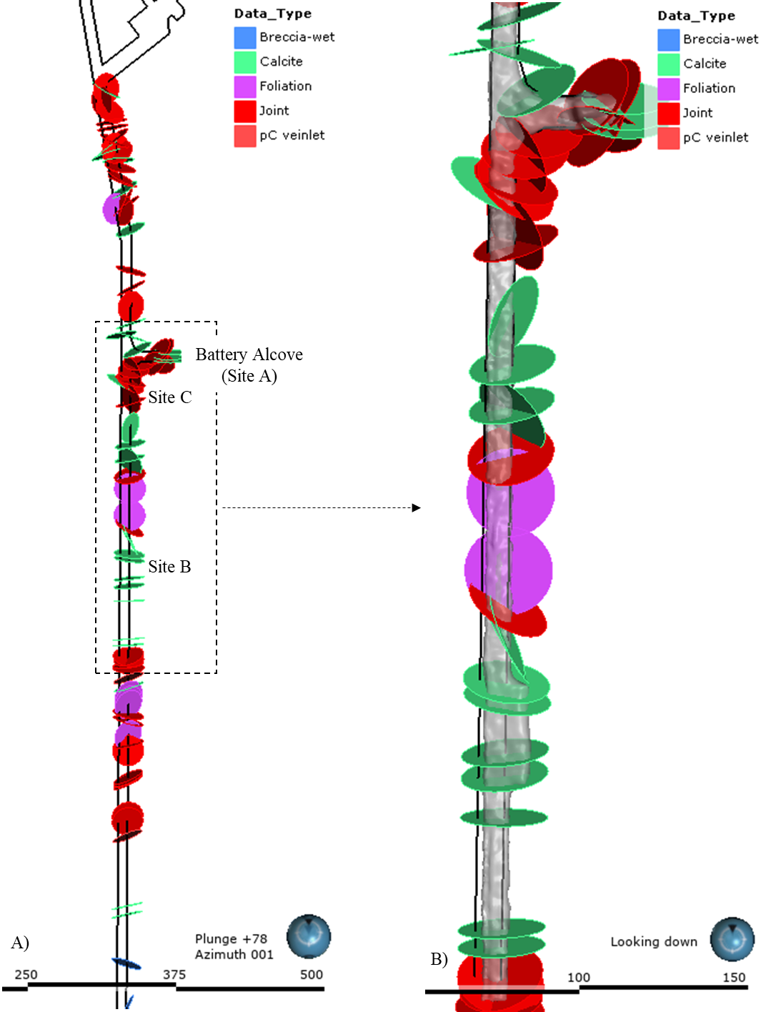
Figure 2. (A) Map showing various fractures identified along the 4100-level drift south from Yates Shaft. (B) Enlarged portion of the map showing fractures at Testbed 2 location. Fracture mapping was conducted on 9/18/2018 and 3/27/2019.
A thin sheared chlorite zone also was identified within the amphibolite in one small area of the battery alcove (upper left of Figure 4). It has a shallowly dipping surface with an orientation different than the overall foliation. This sheared chlorite is likely to be Precambrian in age due to the difference on the effect on the chlorite and the difference in orientation. Identification of additional sheared chloritic zones of this type in the drift are unlikely due to the relatively subtle nature of the zone.
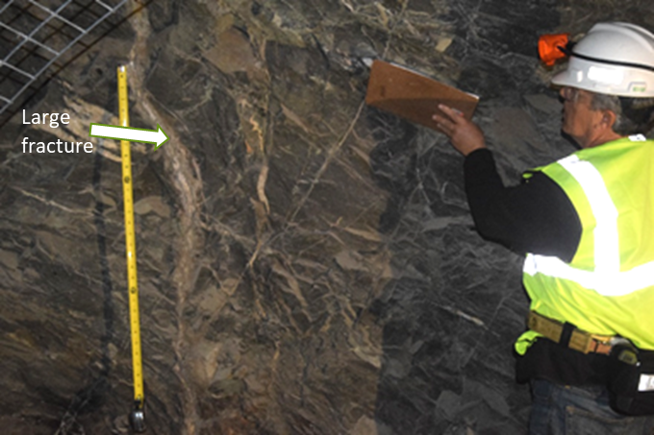
Figure 3. Large fracture near the tape measure for scale (intervals on the tape are 1 ft). The fracture is filled in this photograph but other, similar fractures are exposed in the drift with open space.

3.1.3 Thin Conjugate Shear Sets
Thin fractures can be seen frequently in the fresh face of the battery alcove and may be represented in the drift mapping as well. Fracture widths were very thin (<0.5 mm) and the fractures appear to be healed. They may be a better developed side of a conjugate shear set, as one possibility. Small amounts of offset (~1-2 mm) sometimes can be seen.
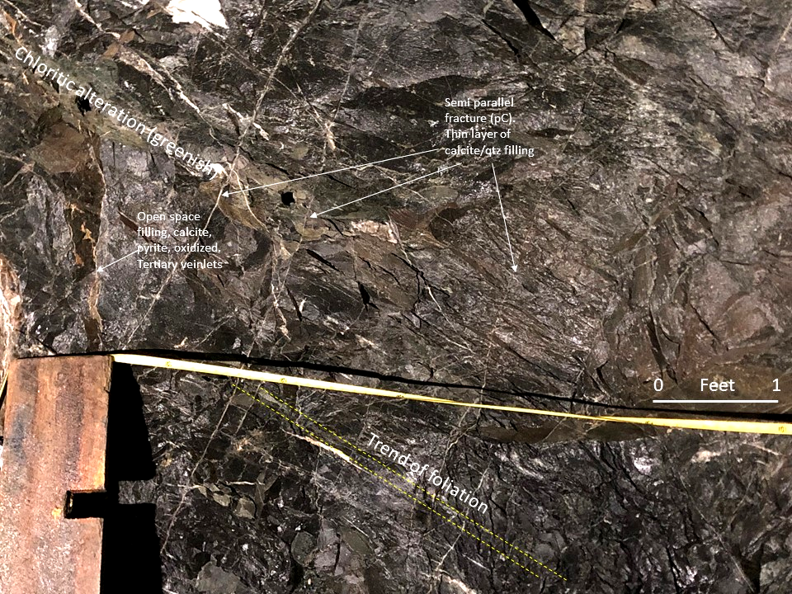
Figure 4. Foliation within the Yates amphibolite dips to the right (south) in this photograph.
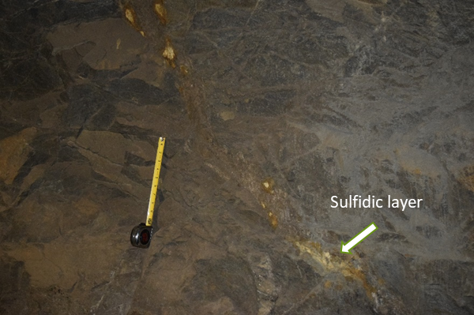
Figure 5. Sulfidic layer exposed in the drift about 60 ft south of the battery alcove.
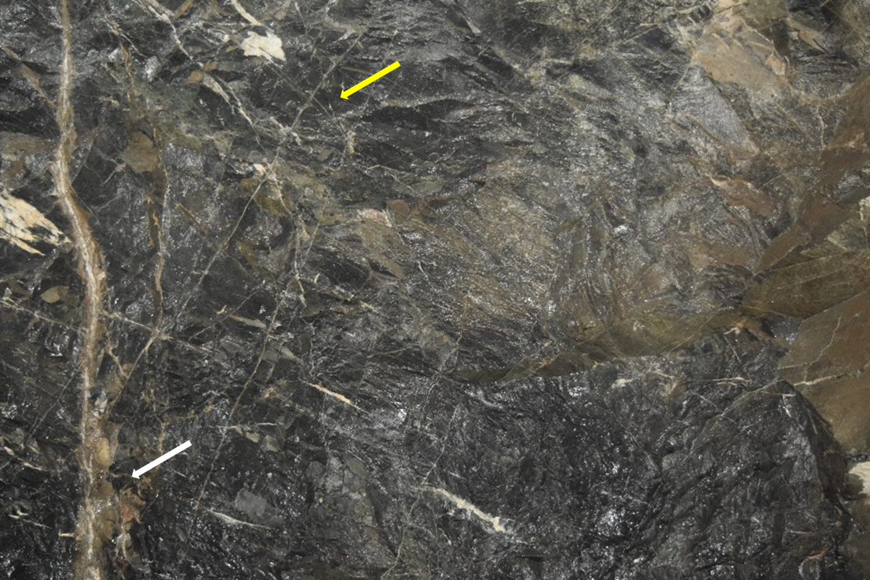
Figure 6. Photo from battery alcove showing the large fracture on the left (white arrow), a conjugate shear in the middle (yellow arrow), and the general orientation of the foliation in the amphibolite.
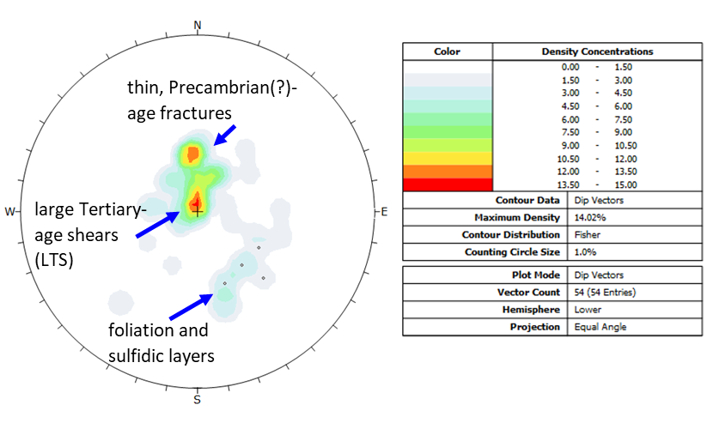
Figure 7. Stereogram of dip vectors showing the foliation in the Yates amphibolite, the large TAS, and the many smaller, healed fractures that may be a better developed side of conjugate shears.
+
+
+
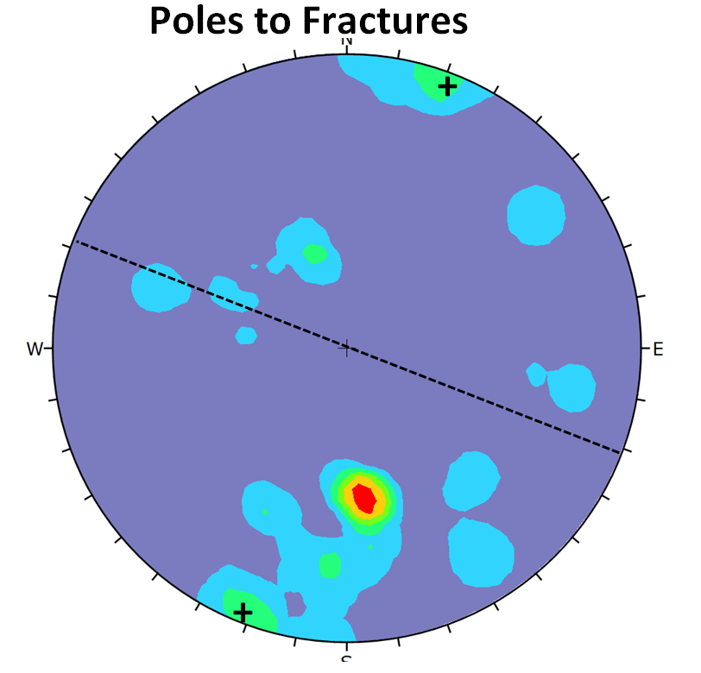
Figure 8. Stereogram of poles of all features and fractures. The crosses show the orientation of the large fracture sets and the dashed line shows the orientation of the nearly vertical fractures striking to the northwest.

3.2 Orientations
A total of 54 measurements of orientations of fractures were taken as part of this work. Figure 5 and 6 show stereograms of the dip vectors of all of the features (Fig. 7) and the pole vectors (Fig. 8). The dip vector plot shows two maxima, and the fractures with the highest dips shown with a (+) are representative of the well-defined shear(?) sets (LTS). The pole vector plot in Figure 8 indicates that these planes strike at ~290º and are nearly vertical.
The second maximum results from measurements of the many thin fractures. These are primarily in the alcove, but thin fractures with similar orientations were found in the drift as well. These features are thought to healed Precambrian fractures due to their degree of filling and general tightness.
Some orientation bias may occur because fractures parallel to the drift would not intersect the drift and, therefore, would not be recognizable although this effect would be rare.

3.3 Projections from the Drift
Two prominent features were found to the north of the battery alcove. One was the well-defined Tertiary fracture shown in Figure 1, and the other was a sulfidic layer in the amphibolite that was semi-parallel to the foliation. A large fracture exposed in the drift (yellow in Figure 9a) is probably the same fracture in the battery alcove face. These are shown in the plan view in a) where they are projected into the area of the battery alcove and in cross-section view in b) in relation to a proposed vertical drill hole. Although the drill hole would not be expected to intersect the larger fracture (yellow), it would be expected to intersect the sulfidic zone (red in Figure 9a) at about 5-10 ft depth in the borehole.
Figure 9a) plan view showing relationship between the battery alcove, a large shear (?) fracture, and a sulfidic zone within the amphibolite. b) the sulfidic zone can be projected downwards towards a probable intersection with the proposed vertical drillhole. Because the large fracture exposed in the east face of the alcove is nearly vertical, it would not be expected to be found in the drillhole.
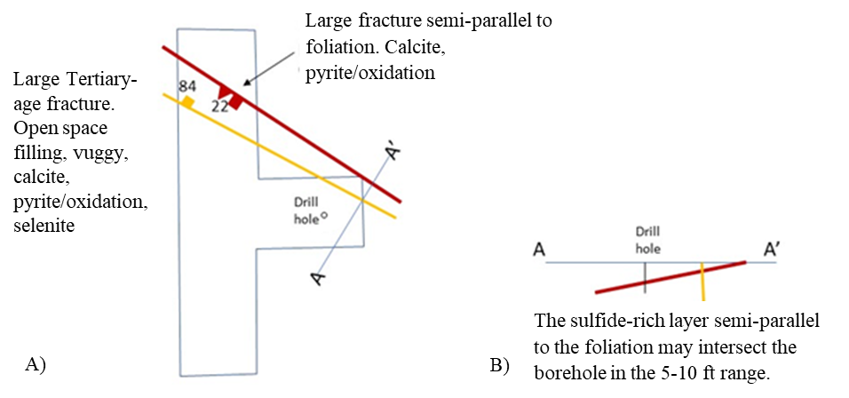
Figure 9. A) plan view showing relationship between the battery alcove, a large shear(?) fracture, and a sulfidic zone within the amphibolite. B) the sulfidic zone can be projected downwards towards a probable intersection with the proposed vertical drillhole. Because the large fracture exposed in the east face of the alcove is nearly vertical, it would not be expected to be found in the drillhole.

3.4 Takeaways
- Three types of fracture systems were identified.
- Many thin, healed fractures with consistent orientations were identified.
- The large, probably Tertiary-age, fractures are good targets but are relatively rare.
- The large fractures are nearly vertical and generally have a NW-SE strike and appear to have some lateral continuity.
- The sulfidic zones appear to be related to the foliation and may be a complicating factor.

4. Fractures in testbed 2 boreholes

4.1 Testbed 2 boreholes
The testbed 2 consists of 9 boreholes drilled from three nearby locations (Sites A, B, and C) along the 4100-level drift south from the Yates Shaft (Figure 10). Initial characterization (identifying rock types, fracture and stress orientations) for testbed layout was investigated by core-drilling two HQ (nominally 96 mm) boreholes with one in the vertical direction (TV4100) and one in the horizontal direction (TH4100) shown in Figure 10B. Following the characterization, an additional nine boreholes (AML, AMU, DML, DMU, TC, TL, TN, TS and TU) were core-drilled to depths ranging from 55 to 80 m to perform controlled hydro shear experiments using TC or TU borehole at Site C.
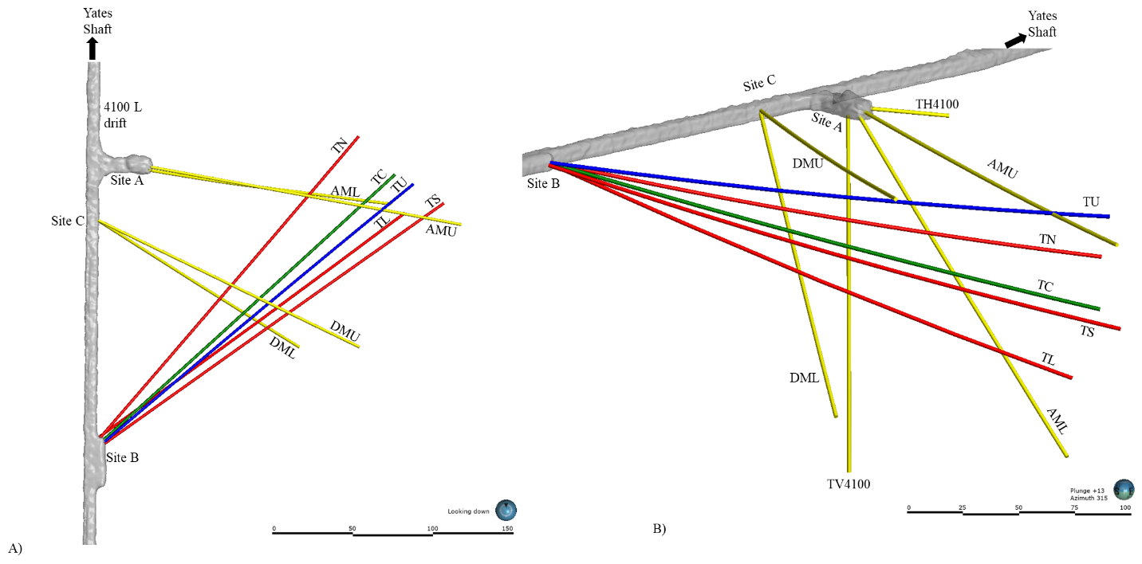
Figure 10. Plan view (A) and cross-sectional view (B) of Testbed 2 boreholes showing Sites A (Alcove), B, and C along the drift on the 4100 level for stimulation and flow experiments.

4.2 Fractures in boreholes (OTV images interpreted by C. Ulrich)
Different methods were used to identify and characterize fractures along the testbed 2 boreholes. During drilling, the recovered cores were observed, logged, and photographed. Besides general descriptions of the lithology, the logs also included presence of fractures and open/voids/vugs, and nature and types of filling minerals, etc. Subsequently, several researchers re-visited achieved cores to study in details to identify alterations, weak zones, fractures, etc. After the completion of drilling, each borehole was scrub-cleaned for acoustic and optical televiewer logs Several other rock properties logs were also prepared using a suite of wireline geophysical tools (Ulrich et al., 2022).
The optical televiewer images were interpretated to identify and pick discontinuity features in boreholes. Three types of discontinuities – foliations, healed fractures, and open fractures - were identified in boreholes. Figure 11 shows examples of open and healed fracture types on the optical televiewer images. All discontinuities picked in testbed 2 boreholes are illustrated in Figure 12. A few of the features are picked as unidentified and labeled as ‘No Data’ category in Figure 12. Majority of the features identified in the boreholes are healed fractures. Figure 13 shows the plots of healed fractures as disks and poles. These healed fractures are distributed as two conjugate sets of fractures, one set of fractures dipping due SW and another group dipping due NW. Another set of healed fractures are nearly orthogonal to the previous two sets with shallower dip due SE.
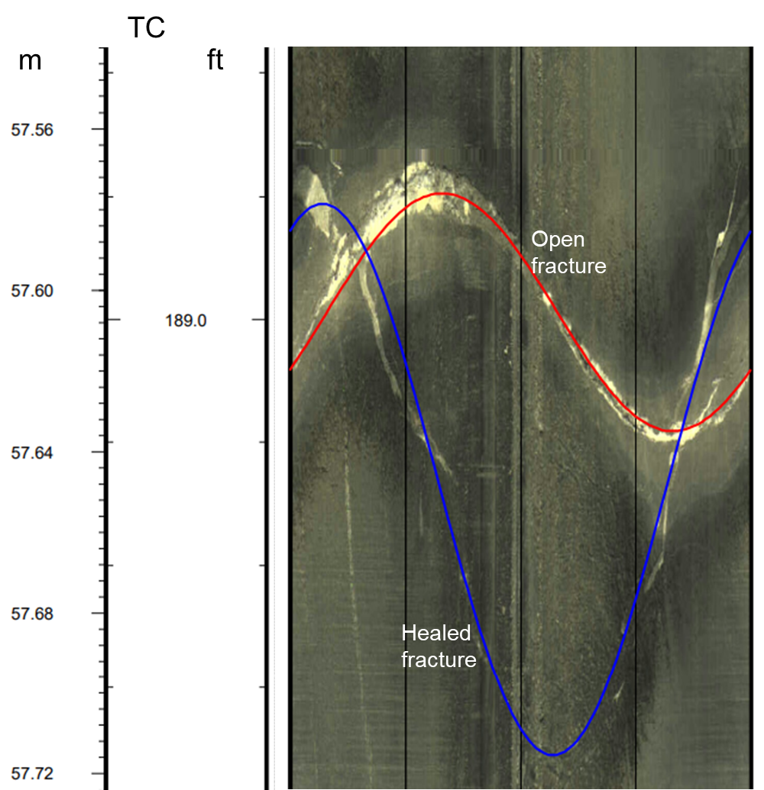
Figure 11. Example of open and healed fractures as observed on the optical televiewer image.
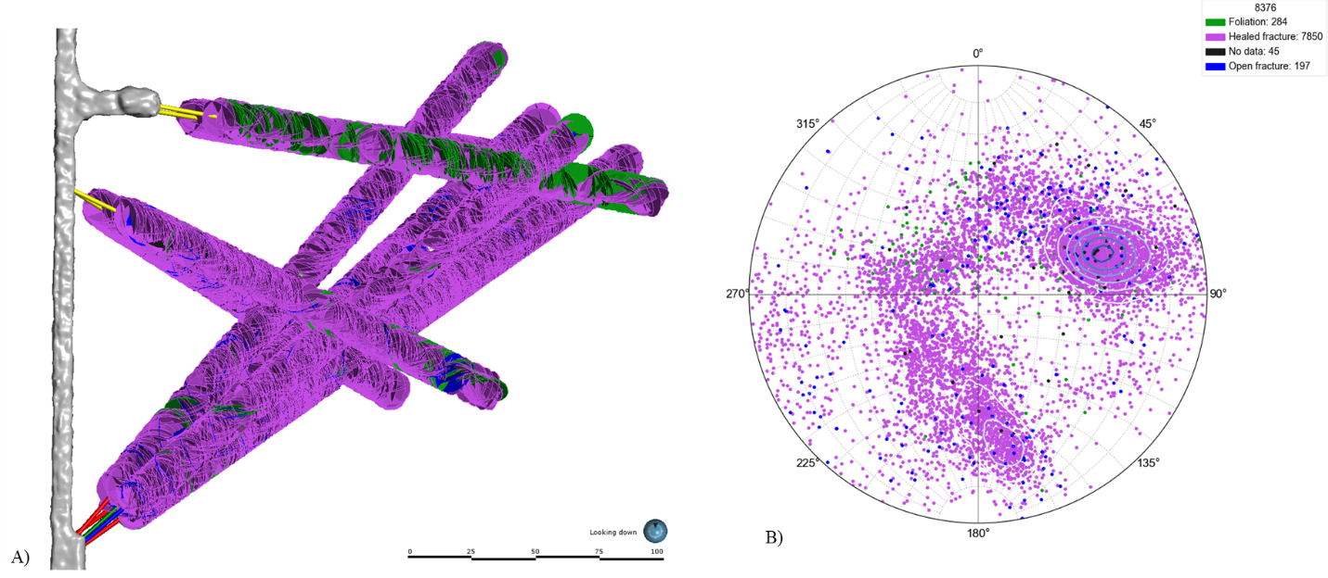
Figure 12. Discontinuity features identified after optical televiewer image interpretation for all testbed 2 boreholes. (A) Discontinuity features plotted as circular disks along the boreholes, and (B) stereonet pole plots (equal angle, lower hemisphere) of the discontinuity features. Foliations are green disks and points, healed fractures are purple disks and points, open fractures are blue disks and points, and unidentified (no data) are black disks and points.
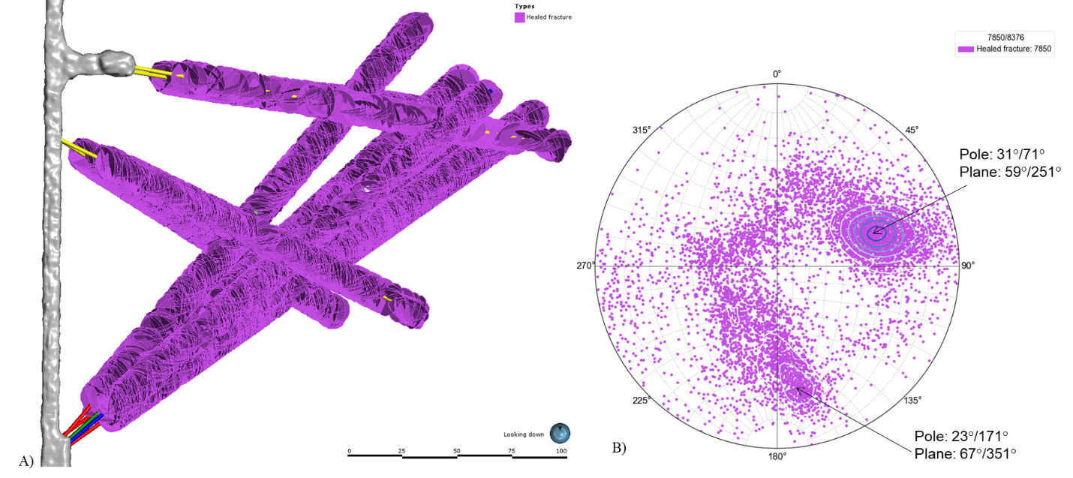
Figure 13. Healed fractures (A) disk and (B) pole plots identified after optical televiewer image interpretation for all testbed 2 boreholes.
Figure 14 shows disk and pole plots for the identified foliations along the testbed 2 boreholes. The distributions of foliation poles (Figure 14B) indicate two major sets of foliations features, the first set being dipping due SW and the second set dipping due SE. Since the foliations in the host rocks are not exhibited prominently, features identified as foliation could be healed fractures. The distributions of these foliations also match with the first and third sets of healed fractures as shown in Figure 13.
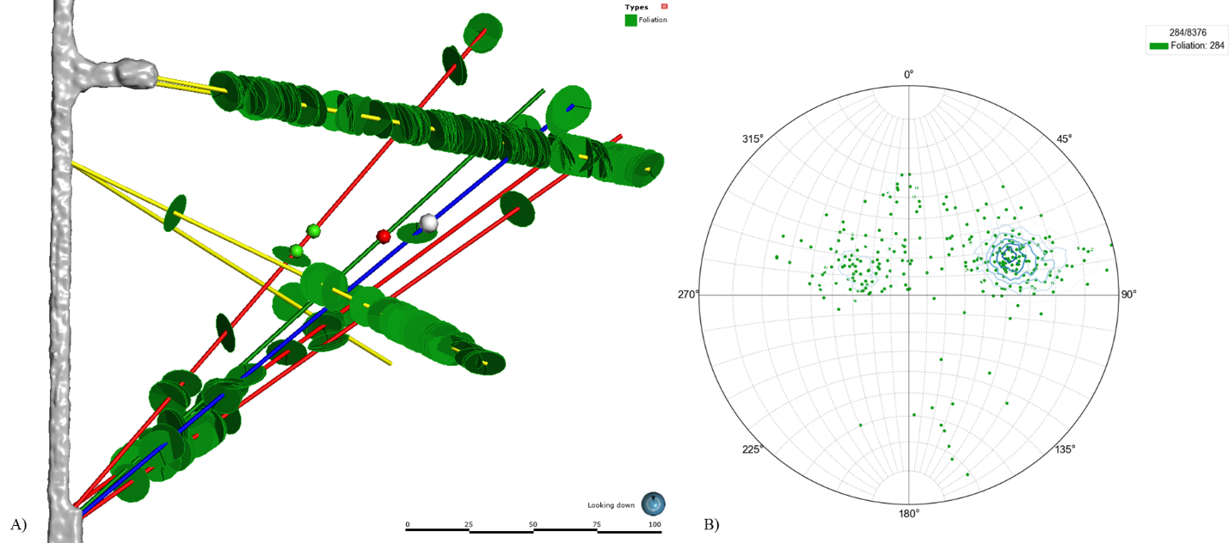
Figure 14. Foliations (A) disks and (B) pole plots identified after optical televiewer image interpretation for all testbed 2 boreholes.
The open fractures (Figure 15) are discontinuities with observable open space or vugs identified in the optical televiewer logs (images). The pole distribution plot for the open fractures (Figure 14B) shows three sets of open fractures, with two fracture sets correlating with healed fractures. The third set of open fractures are dipping due NE and have steeper dip angle, and mostly correlate with Tertiary fracture mapped in the drift (Figure 9A).
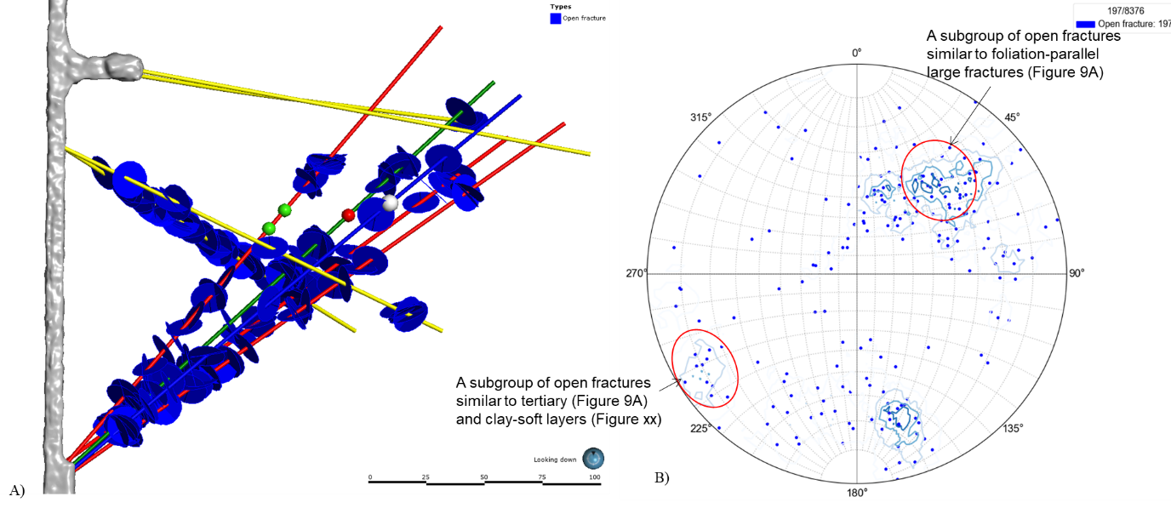
Figure 15. Open fractures (A) disks and (B) pole plots identified after optical televiewer image interpretation for all testbed 2 boreholes.

4.3. Features in the boreholes (examination of core photos, by W. Roggenthen)
Examinations of core photos revealed some interesting features such as alteration seams, calcite and quartz calcite veins (ranging from ~1-2 cm to as large as ~1 m), fractures lined with non-calcite/quartz minerals (e.g., anhydrite), and open spaces along the boreholes. Figure 16A shows three feature types represented by pink, altered, and space. The features represented by pink are fractures lined with minerals other than calcite or quartz. These features are taken from the core description sheets rather than identifying in core photos. The features represented by altered are seams that show chemical changes from amphibolite to minerals such as clay or in many instances, are just a color change to a “non-amphibolite” color. Finally, the features illustrated as space are open space in the core which include large open spaces and microporosity.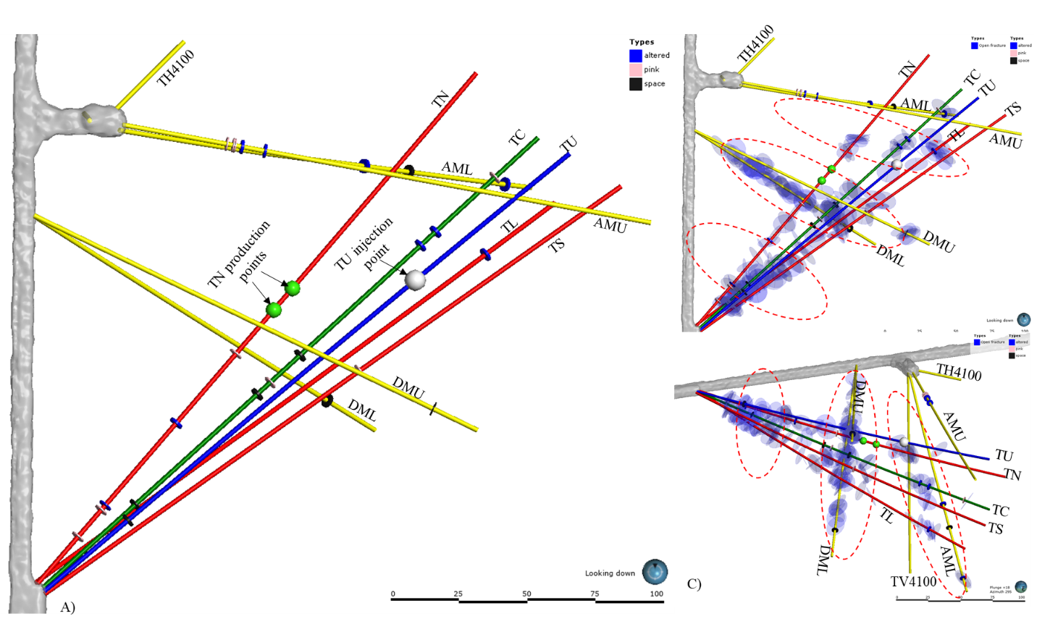
Figure 16. (A) Features identified during examinations of core photos. Pink features are fractures lined with minerals other than calcite or quartz, altered features are seams of clay or other non-amphibole minerals, and space features are large open spaces and microporosity. (B & C) Core examination features plotted along with open fractures identified by interpretation of optical televiewer images.

Figures 16B&C show core examination features along with open fractures identified by interpretation of optical televiewer images. The distributions of these features indicate that these features are concentrated along repeating NW-SE extending zones. The general orientations of these zonal patterns appear to be similar in orientations to that of the large Tertiary fracture in the drift (Figure 3), and likely to be related to deformations related to the Tertiary rhyolitic intrusions.

5. Stimulated fracture zones and flow paths

5.1 Tertiary fracture and clay/soft layers
Testbed 2 has very few discontinuity features that can be traced from one borehole to the others. Features that has some similarities in properties and locations are clay/soft section noticed in TC and TL (as shown in Figure 17A). However, during low-pressure hydraulic tests prior to stimulations, cross flow between these sections were not observed. Nevertheless, these features in TC and TL have similar orientations as that of the large Tertiary fracture mapped in the drift (Figure 3). These fractures also share the general strike directions of the hydraulic fractures created at the deeper sections in the TV4100, but they differ in dip directions. (Figure 16B).
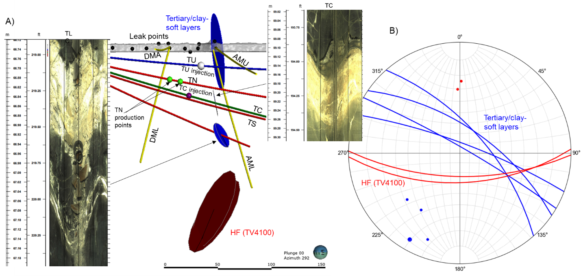
Figure 17. (A) Orientations of Tertiary fracture and clay/soft layers in TC and TL in the testbed. (B) Stereonet plot showing Tertiary fracture and clay/soft layers and TV4100 hydraulic fractures.

5.2 DTS anomalies and open fractures
Several DTS anomalies (Figure 18A) were recorded mostly during the long-term flow tests with injection in TU. Only one DTS anomaly was detected at 111.55 ft in AMU on 4/12/2022 during TC stimulation at interval between 192.4-200.3 ft. Several DTS anomalies were detected along DML and DMU during flow tests TU with the interval centered at 178.7 ft (Figure 18A). Open fractures picked after interpretation of DML and DMU optical televiewer images are included in Figure 18B along with the DTS anomalies. Each DTS anomaly appears to be associated with an open fracture, with slight offset for an anomaly at 141 ft in DMU. It is likely that the open fractures provided a pathway for high-pressure fluid to intersect the grouted DML and DMU from main activated fracture zones (discussed below) and caused positive temperature anomaly through Joule-Thomson heating due to pressure drops. Although open fractures were not picked along AML and AMU, a higher number of open fractures were identified in TC, TU, and TL nearby these anomalous points, indicating creation of potential flow paths to AML and AMU DTS anomaly points (Figure 18C).
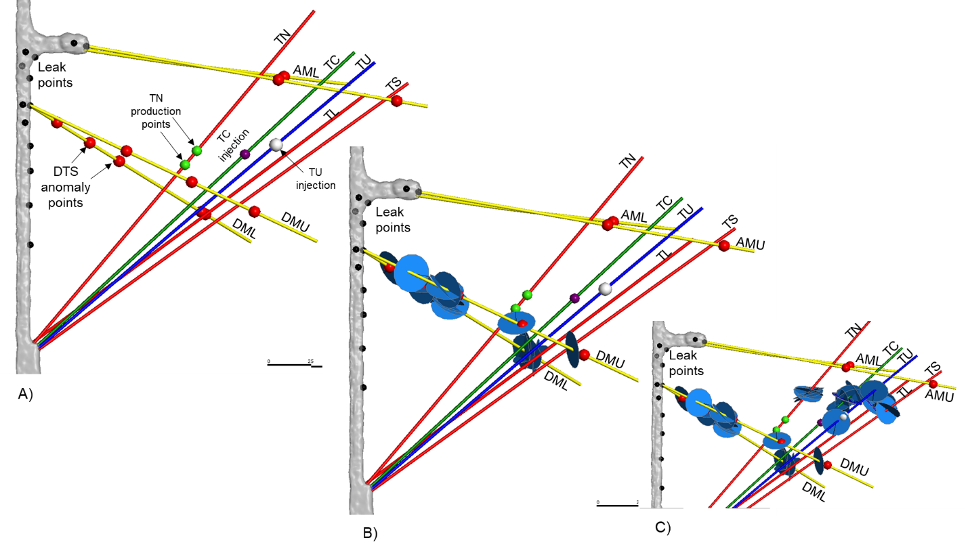
Figure 18. (A) DTS anomalies (red spheres) along AML, AMU, DML, and DMU. (B and C) Open fractures plotted along with DTS anomalies.

5.3 ERT anomalies and open fractures
Figure 19 shows the changes in electrical conductivity measured on July 27 after injection of sodium chloride electrolyte on July 26. Higher positive changes in electrical conductivity are observed in areas with higher density of open fractures in the testbed.
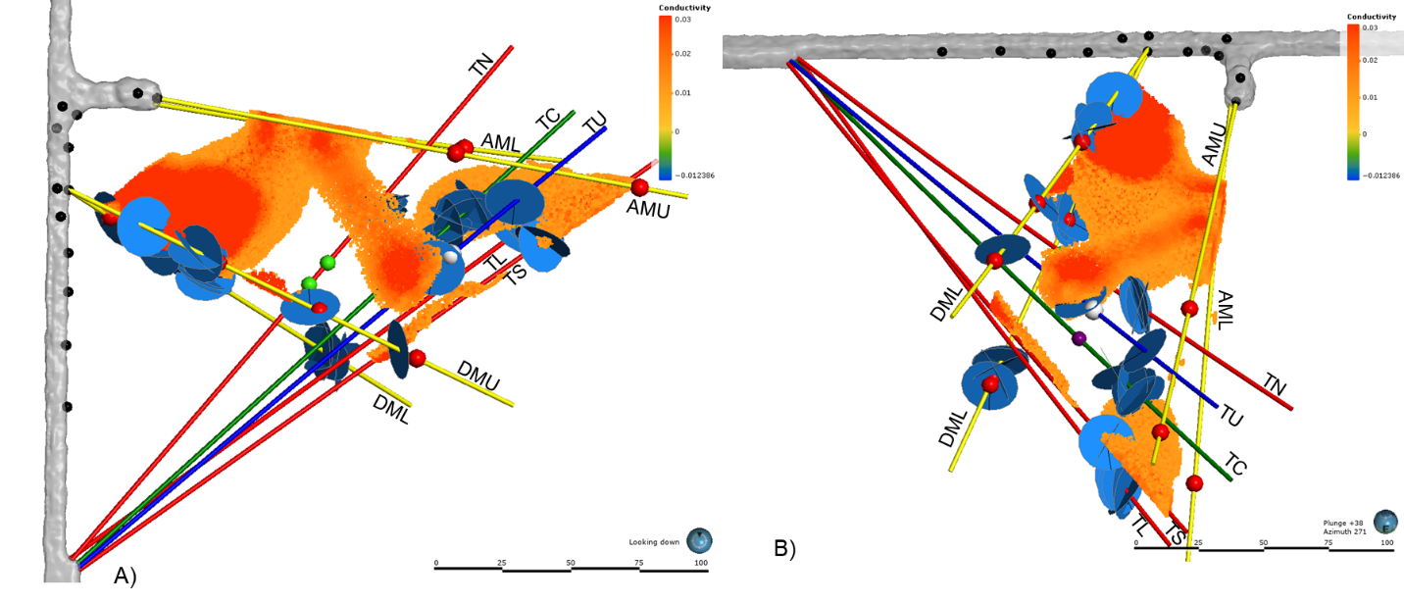
Figure 19. ERT results showing positive electrical changes in the testbed. (A) Plan and (B) elevation views of the testbed 2. The higher (>0.01) positive changes in electrical conductivity (log S/m)) after injection of saline water is illustrated with hotter-colored cells. The cells with lower positive changes in electrical conductivity are filtered out.

5.4 MEQ locations and fracture zones
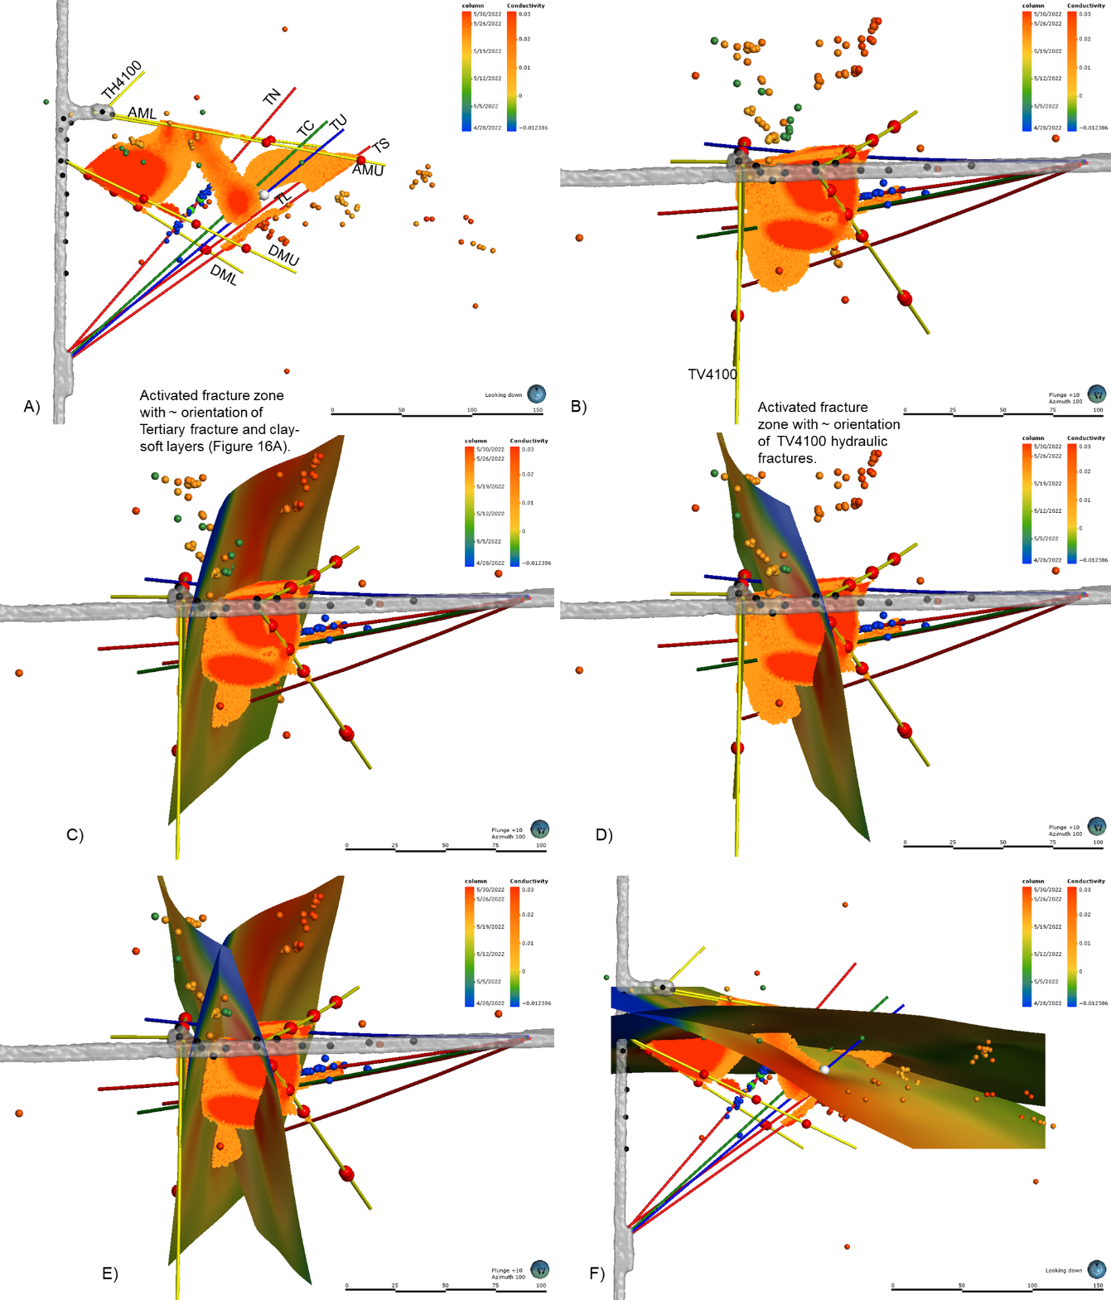
Figure 20. Plan (A) and elevation (B) views of distribution MEQ locations along with ERT results. (C and D) visually fitted surfaces along two sets of MEQ locations, one surface has orientation similar to that of the large Tertiary fracture and soft/clay layers in TC and TL (Figure 17) whereas the surface has orientation similar to the hydraulic fractures created in TV4100 (Figure 17). Elevation (E) and plan (F) views with both surfaces. These surfaces represent the activated fracture zones that provide fluid flow paths to different production points. Color in these fracture surfaces represented electrical conductivity values evaluated from ERT results.
Figure 20 shows distributions of MEQ locations detected during 4/28/2022 to 5/29/2022 along ERT results. As illustrated in Figure 20B, the distributions of MEQ locations can be associated with two intersecting planner features, loosely defined as activated fracture zones. One of the fracture zones has orientation similar to that of the large Tertiary fracture and soft/clay layers in TC and TL whereas the other fracture zone has orientation similar to those of the hydraulic fractures created in TV4100 (Figure 17).
Finally, Figure 21 shows an integrated illustration for the two fracture zones along with other observational and monitoring data. The available observational evidence suggests that the testbed 2 is likely to have two intersecting activated fracture zones. The intersection of these two fracture zones seems to be controlled by the existing open fractures. Majority (up to 70%, Mattson et al., 2023) of the injected water into TU appears to be flowed through these fracture zones to the drift between Site C and Site A corner. A fraction of injected (~30%) water was intercepted by production zones in TN.
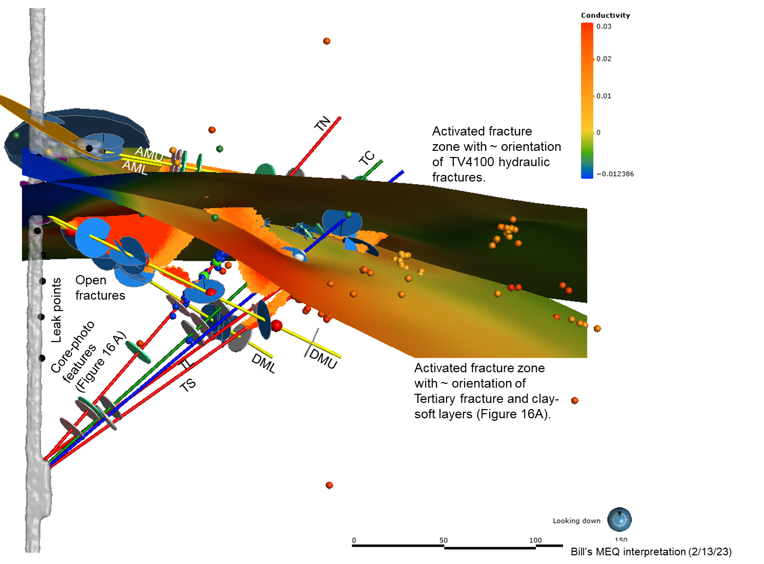
Figure 21. Stimulated fracture zones integrated with various observational and monitoring data.

References
Caddey, S.W., R.L. Bachman, T.J. Campbell, R.R. Reid, and R.P. Otto. 1991. The Homestake Gold Mine, An Early Proterozoic Iron-Formation-Hosted Gold Deposit, Lawrence County, South Dakota. U.S. Geological Survey Bulletin 1857-J, 67 p.
Mattson, E., Plummer, M., Neupane, G., Vermeul, V., Sirota, D., Ingraham, M., Kneafsey, T. and Team, T.E.C., 2023. Fluorescein Tracer Testing on the 4100L–A Preliminary Examination of Initial Arrival in Wells and the Drift at the Second EGS Collab Testbed. In 48th Workshop on Geothermal Reservoir Engineering, Stanford University, Stanford, California.
Ulrich, C., Dobson, P.F., Kneafsey, T.J., Roggenthen, W.M., Uzunlar, N., Doe, T.W., Neupane, G., Artz, T., Dobler, K., Schwering, P. and Smith, M., 2022, June. Characterizing rock fractures and physical properties for Experiment 2 of the EGS Collab Project, Sanford Underground Research Facility. In 56th US Rock Mechanics/Geomechanics Symposium. OnePetro.

